**Setting Up Jenkins Pipeline to Deploy Docker Swarm**

**Code:**

**Producer**

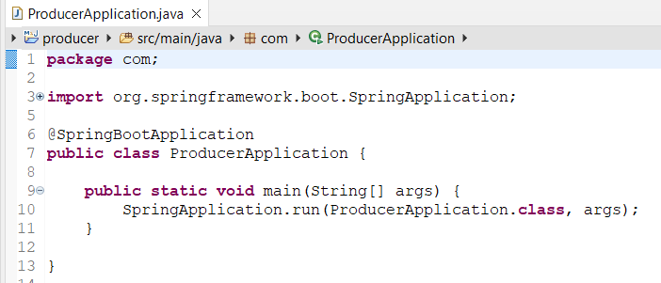

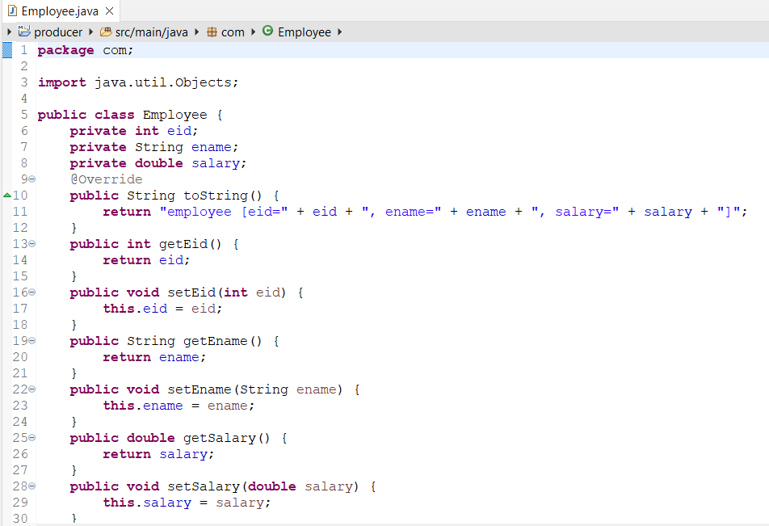

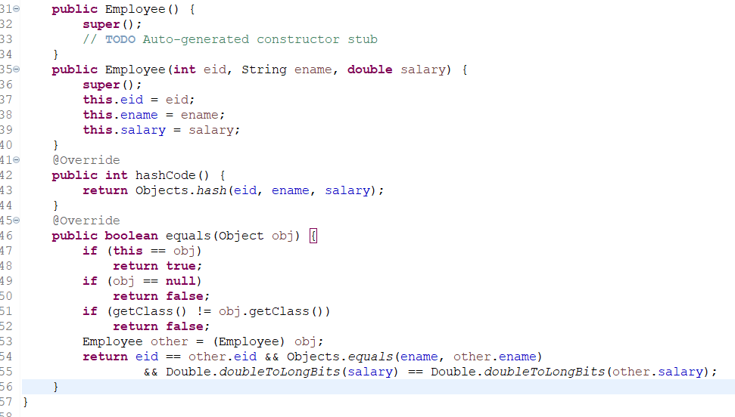

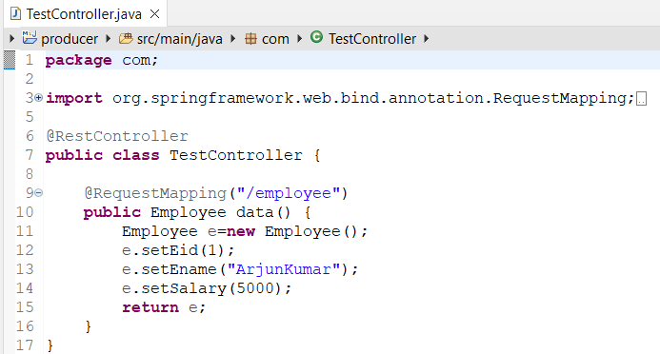

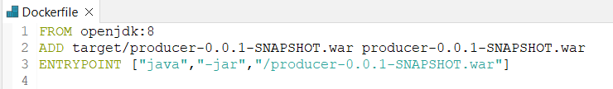

**Consumer**

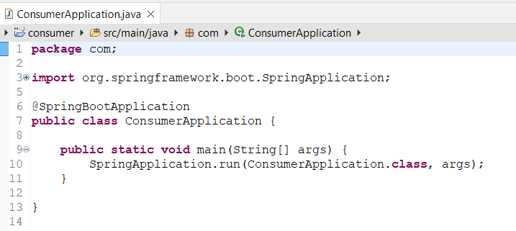

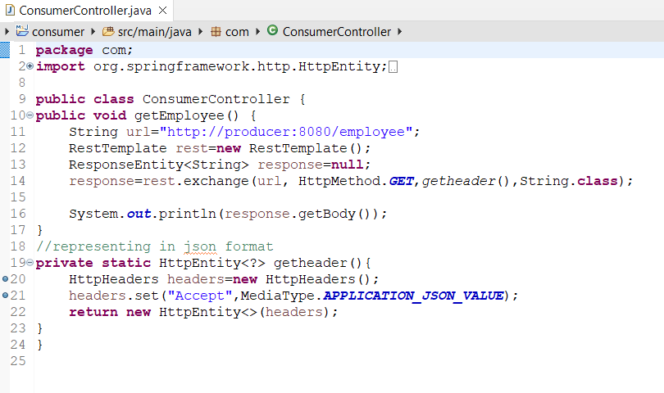

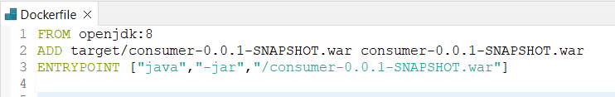

**Jenkins**

**Producertesting**

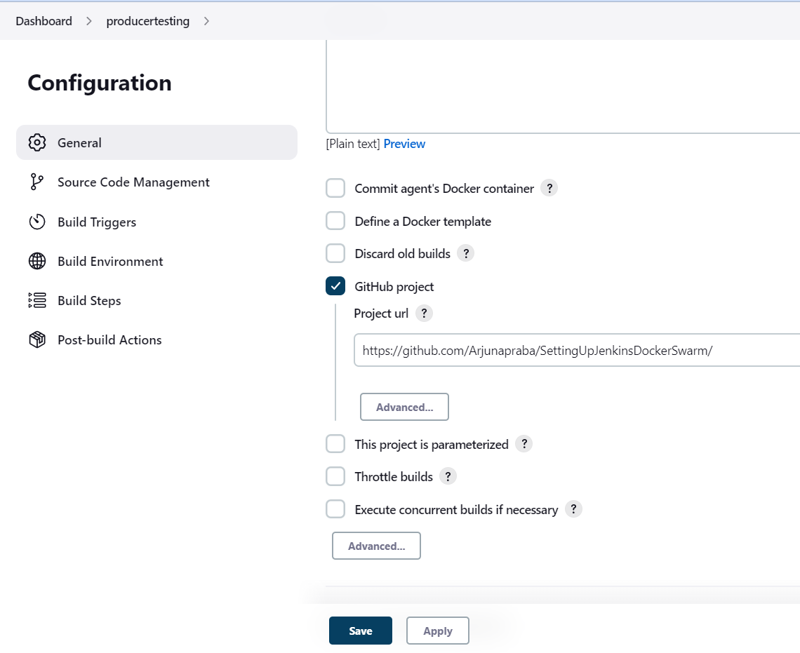

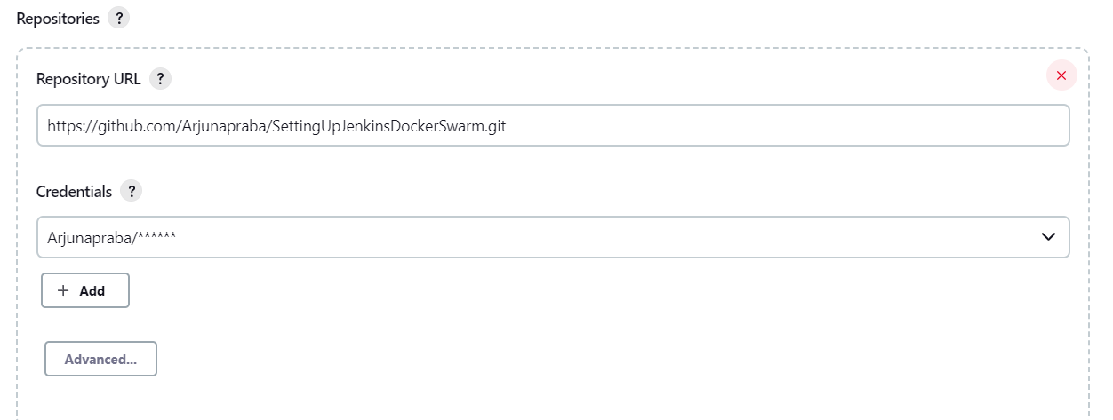

**Build and Publish in Docker**

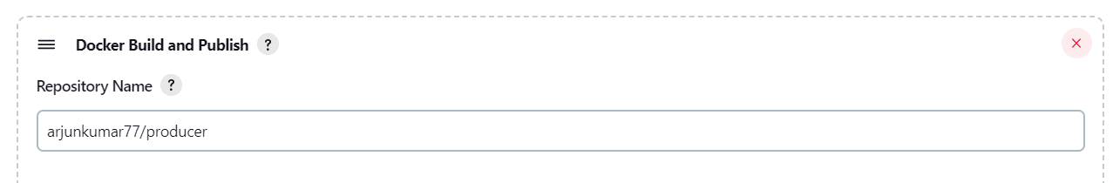

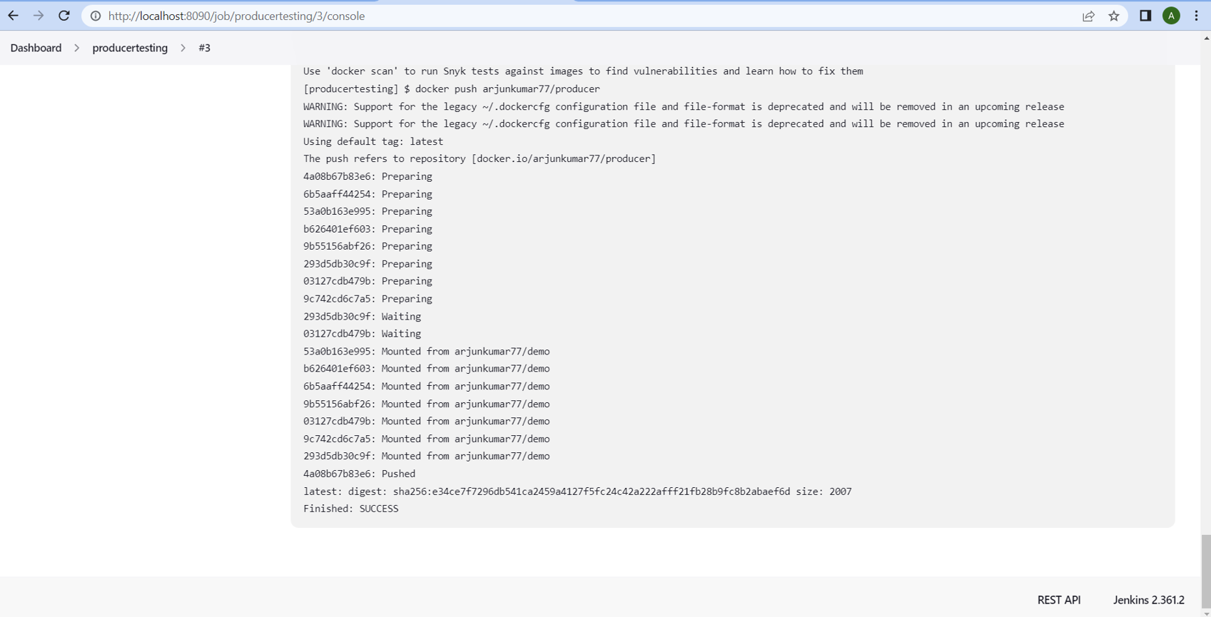

**Consumertesting**

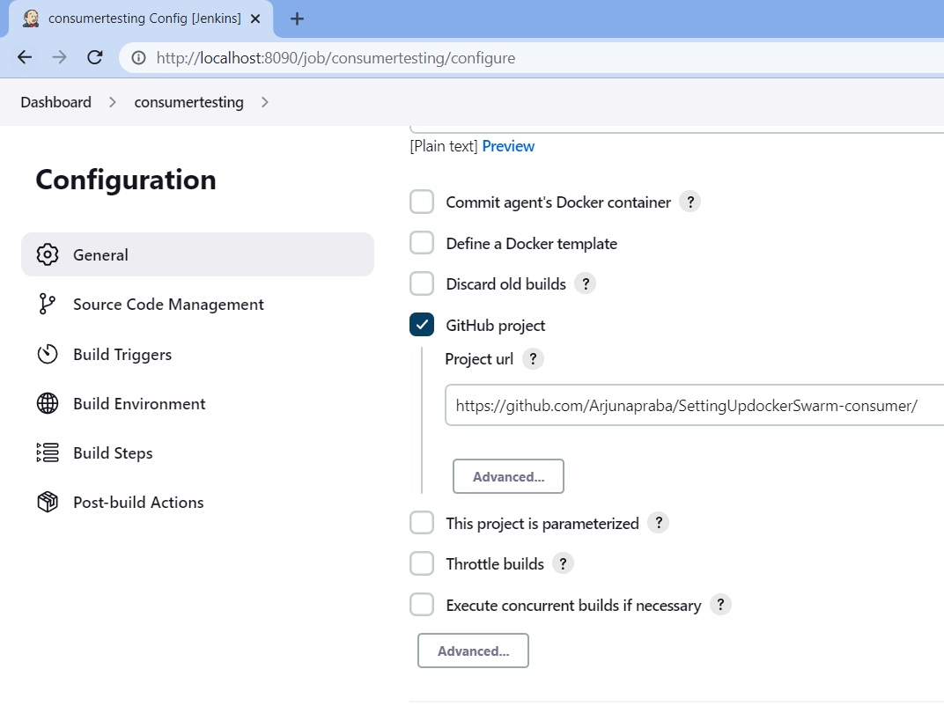

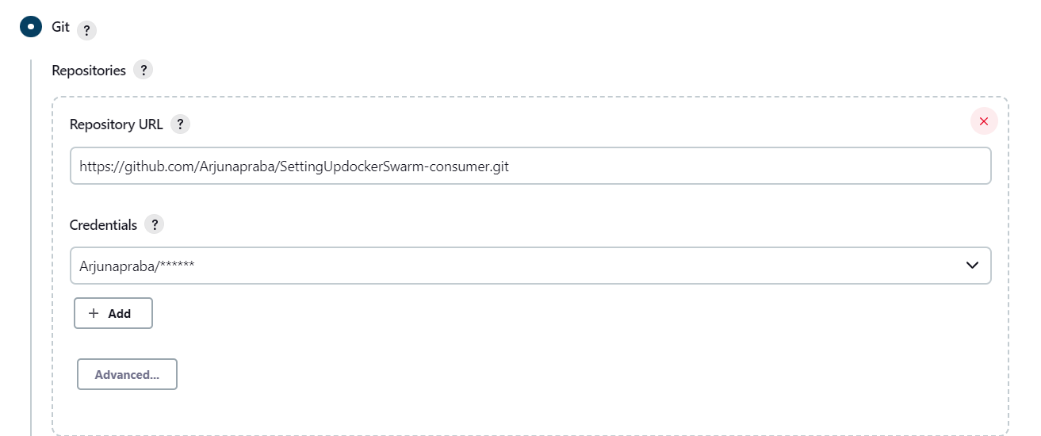

**Build and Publish in Docker**

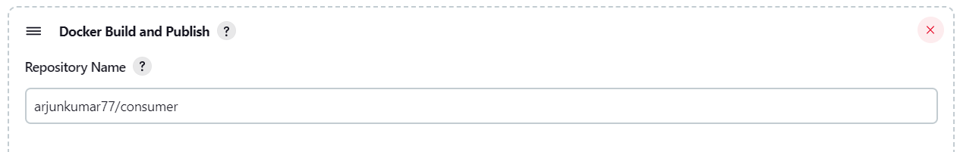

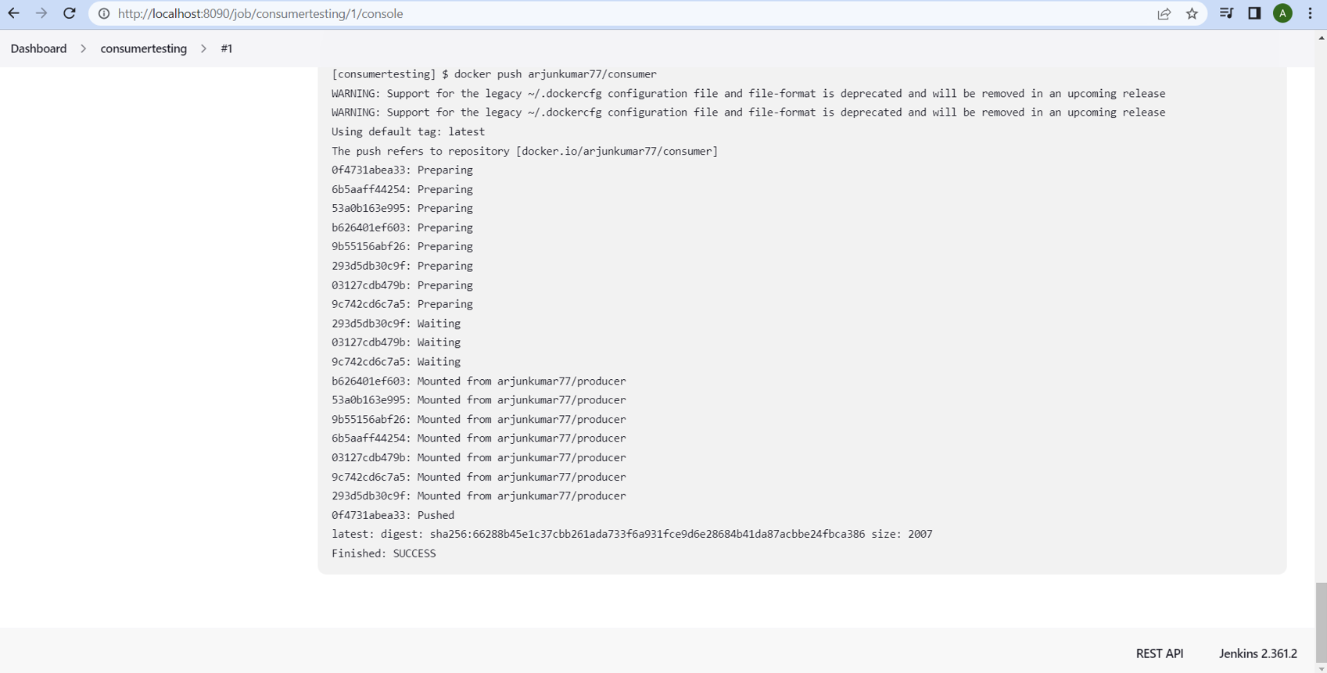

**AWS**

**Create two instances**

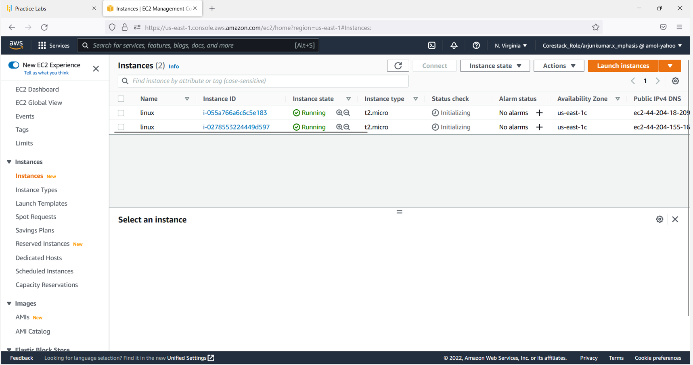

**1inux instance1**

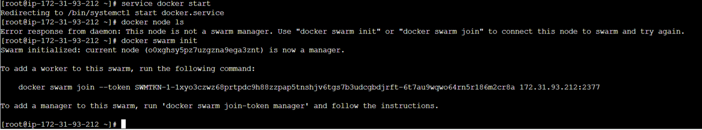

**Put docker swarm join in instance2**

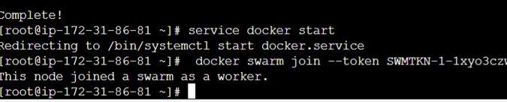

**In instance1**

**vi dockerconfig.yaml**

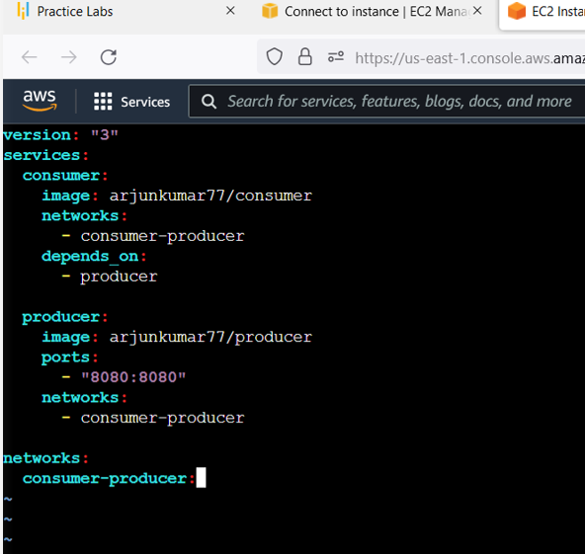

**deploy**

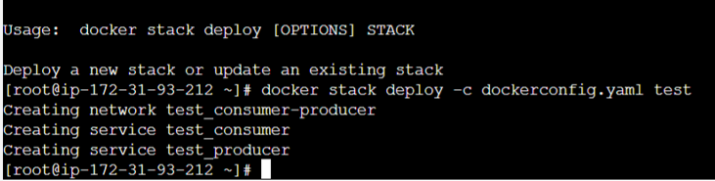

**docker service**

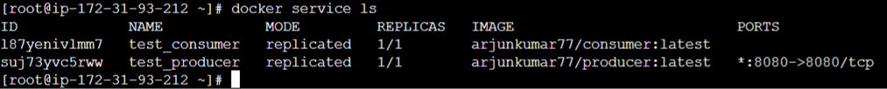

**instance1**

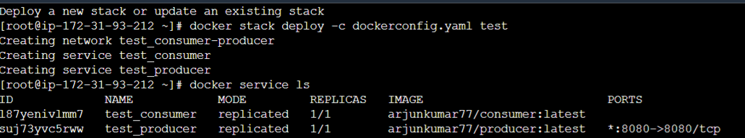

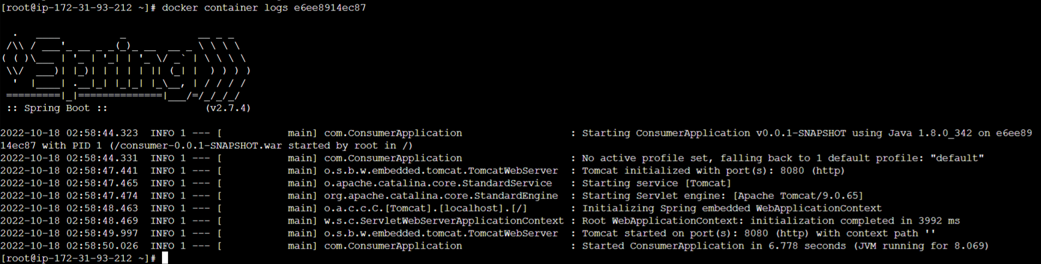

**Instance2**

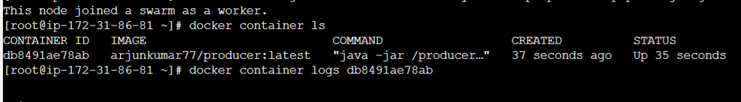

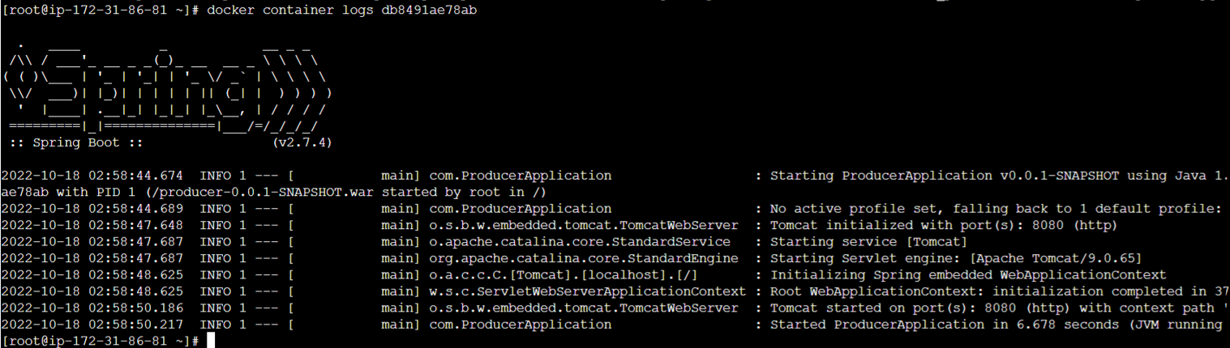

**Copy and paste the instance URL of node joined swarm as worker in browser**

